**QUESTION:**

Determine the current offset after closing the switch for the following cases:

1)No DC offset

2)Maximum DC offset

3)When alpha=0

4)When alpha=pi

**CODE:**

clc

clear all

R=0.125;

L=0.01;

w=377;

XL=w*L;

Vm=151;

Z=sqrt(R.^2+(w*L).^2);

theta=atan(XL/R);

t=0:0.00001:1;

%i=(-Vm*exp((-R/L)*(t))*sind(alpha-theta));

%for no dc offset

%sind(alpha-theta)=0

alpha=theta;

i1=(Vm/Z)*sin(w*t+alpha-theta)-(Vm*exp((-R/L)*(t))*sin(alpha-theta)/Z);

%for max dc offset

%sind(alpha-theta)=-90

alpha=-1.57 +theta;

i2=(Vm/Z)*sin(w*t+alpha-theta)-(Vm*exp((-R/L)*(t))*sin(alpha-theta)/Z);

%if alpha=0

alpha=0;

i3=(Vm/Z)*sin(w*t+alpha-theta)-(Vm*exp((-R/L)*(t))*sin(alpha-theta)/Z);

%if alpha=pi

alpha=3.14;

i4=(Vm/Z)*sin(w*t+alpha-theta)-(Vm*exp((-R/L)*(t))*sin(alpha-theta)/Z);

subplot(4,1,1)

plot(t,i1)

title('Subplot 1: NO DC OFFSET');

xlabel('Time (sec)');

ylabel('Current (A)');

subplot(4,1,2)

plot(t,i2)

title('Subplot 2: MAXIMUM DC OFFSET');

xlabel('Time (sec)');

ylabel('Current (A)');

subplot(4,1,3)

plot(t,i3)

title('Subplot 3: WHEN ALPHA=0');

xlabel('Time (sec)');

ylabel('Current (A)');

subplot(4,1,4)

plot(t,i4)

title('Subplot 3: WHEN APLHA=PI');

xlabel('Time (sec)');

ylabel('Current (A)');

**GRAPH:**



**SIMULINK MODEL:**

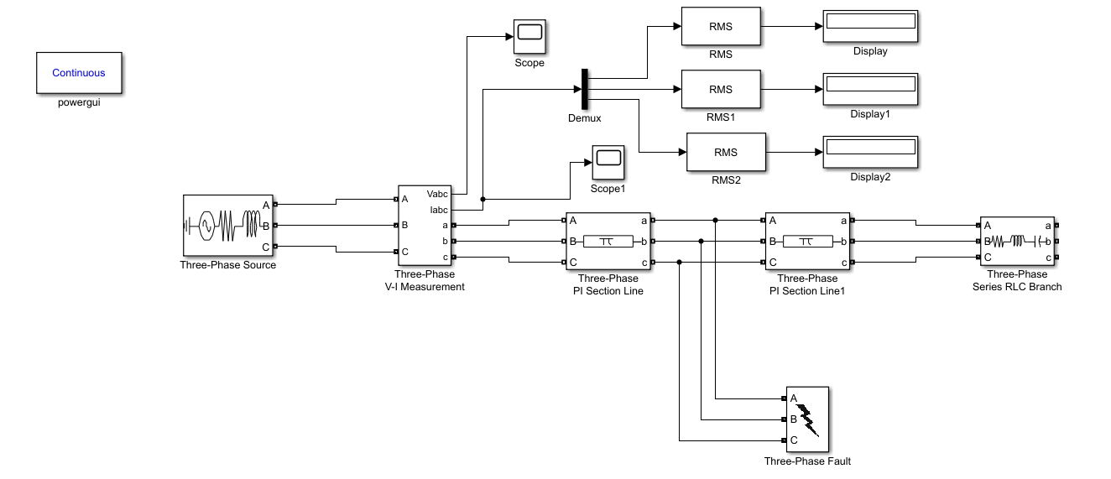

**SCOPE OUTPUTS:**

**1)Phase A to Ground**

Voltage Time Graph



Current Time Graph



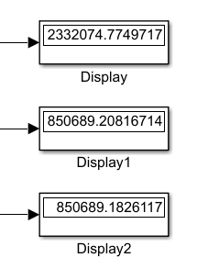

**Ia**

**Ib**

**Ic**

**2)Phase B to Ground**

Voltage Time Graph



Current Time Graph



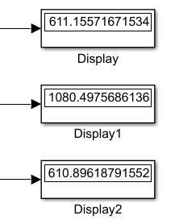

**Ia**

**Ib**

**Ic**

**3)Phase C to Ground**

Voltage Time Graph



Current Time Graph



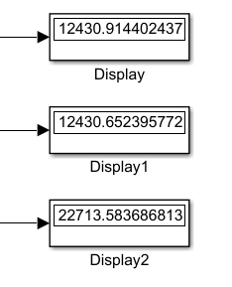

**Ia**

**Ib**

**Ic**